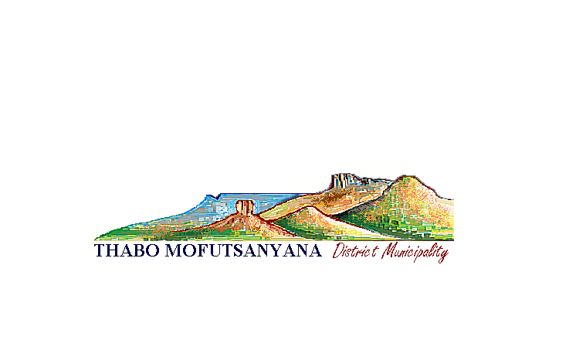

MAMPOI STREET, OLD PARLIAMENT BUILDING, PRIVATE BAG X810, WITSIESHOEK 9870, SOUTH AFRICA
: +27 (58)-718 1006 : +27 (58)713 2408 evelyn.tm@lg.fs.gov.za
____________________________________________________________________________________________________________
Enquiries:Mr H.I Lebusa
Cell:082 805 4156
Tel: 058 713 4485

05 March 2015

Senior executive manager
Provincial Treasury
Private bag x20537
Cnr.Markgraaf & Elizabeth Street
Provincial government building 13th floor
Bloemfontein
9300

Sir/Madam

SECTION 71 REPORTS AS PER MFMA (FEBRUARY 2015)
Kindly receive a monthly report for February 2015 in compliance with MFMA section 71(1) and this report will be e-mailed to lgdatabase@treasury.gov.za

We hope you will find it in order.

COMPILED BY : ………………………………………….
H I LEBUSA
CHIEF FINANCIAL OFFICER

SUBMITTED BY : …………………………………………
TPM LEBENYA
MUNICIPAL MANAGER

NOTED BY : ………………………………………….
CLLR.M VILAKAZI
EXECUTIVE MAYOR

_________________________
MR BENNETT MOLOTSI
MUNICIPAL MANAGER

MAMPOI STREET, OLD PARLIAMENT BUILDING, PRIVATE BAG X810, WITSIESHOEK 9870, SOUTH AFRICA
: +27 (58)-718 1036/ 89 : +27 (58)718 1034 loraine.tm@lg.fs.gov.za, tekas.tm@lg.fs.gov.za
____________________________________________________________________________________________________________
OFFICE OF THE MUNICIPAL MANAGER
Enquiries:Mr H.I Lebusa
Cell:082 805 4156
Tel: 058 713 4485
28 March 2014
Ms.Linda Kruger
National Treasury
40 Church Square
PRETORIA
0002

Sir/Madam

APPROVED DRAFT BUDGET 2014/2015 FINANCIAL YEAR

In compliance with section 28(7) read together with section 22(b)(i) of the MFMA No.56 of 2003 kindly receive the approved Draft budget 2014/2015 tabled before Council on the 27 March 2014.

The following copies are attached thereof:

- Hard Copy of the Draft budget 2014/2015 MTREF
- Soft Copy of the Draft Budget 2014/2015 MTREF
- Soft Copy of Budget related policies
- Council resolution on the Draft Budget 2014/2015 MTREF
- Municipal Manager `s quality certification

We hope you will find it in order

Thank you

_________________________
MR BENNETT MOLOTSI
MUNICIPAL MANAGER

